**Kubernetes Deployment via CICD pipeline (CIRCLECI)**

**Lint Issue (purposely added)**

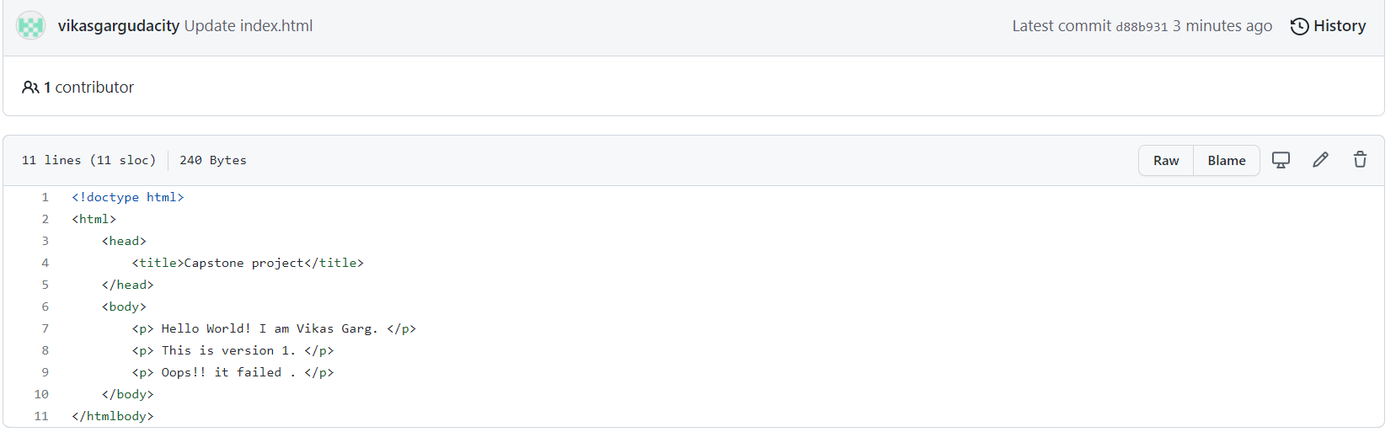

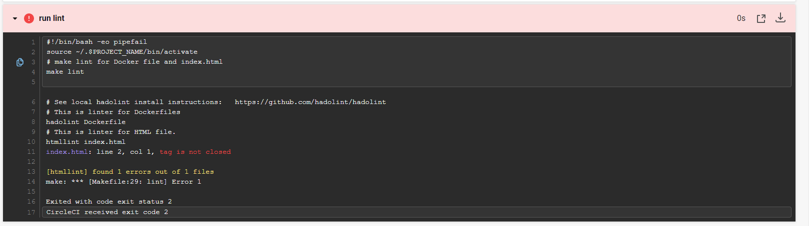

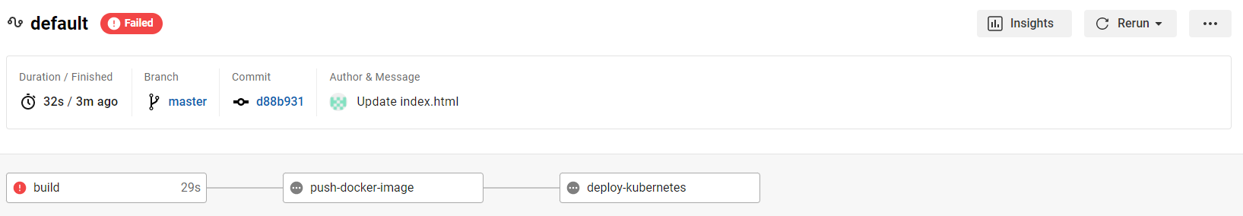

**Lint Issue Resolved – Successful Pipeline**

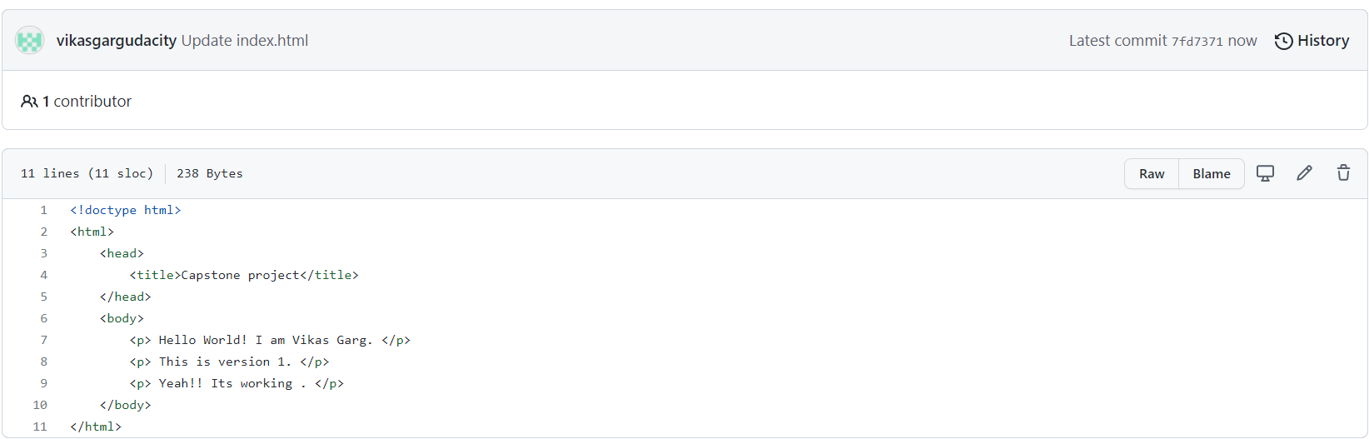

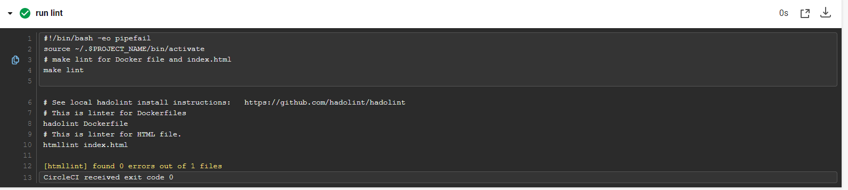

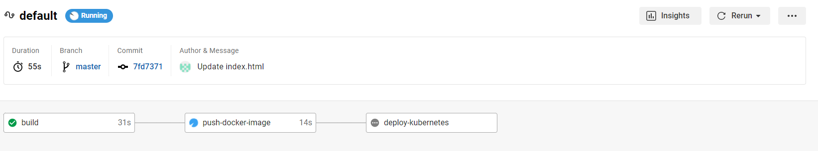

**Docker Image build and Upload:**

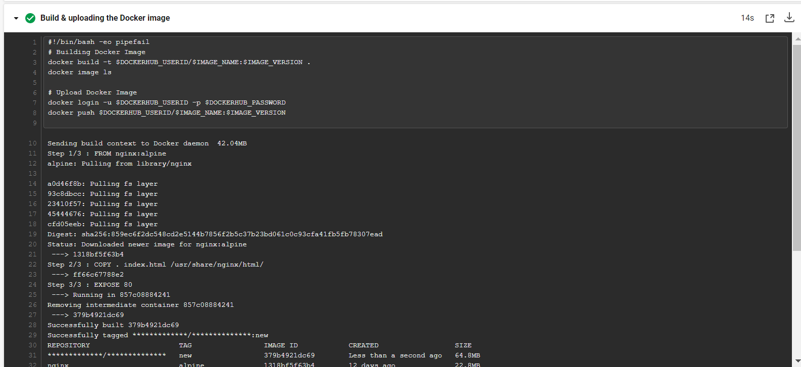

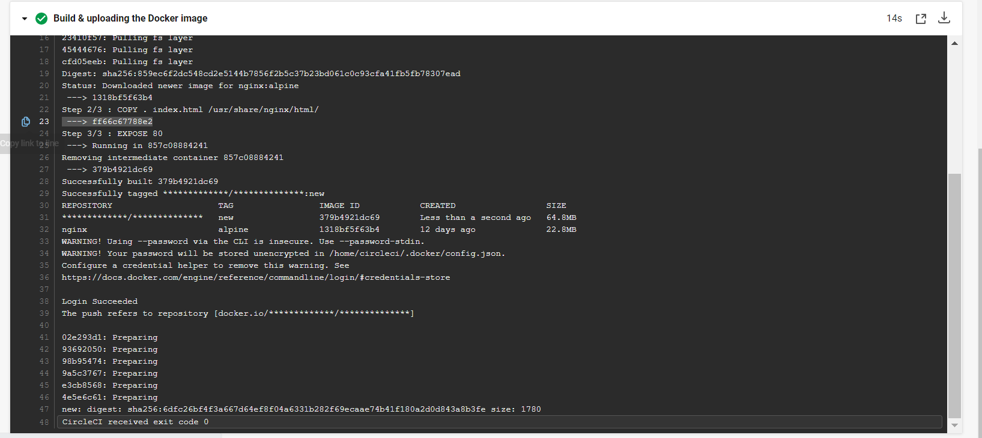

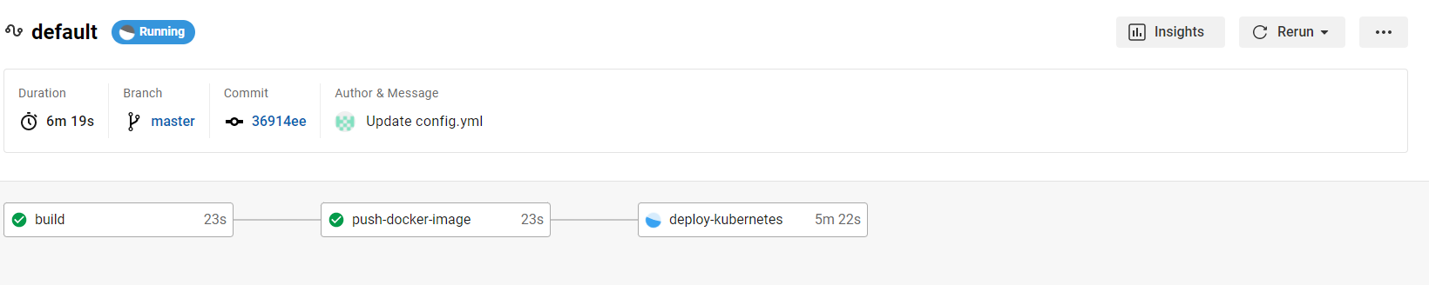

**Kubernetes Create Cluster, deployment and Services**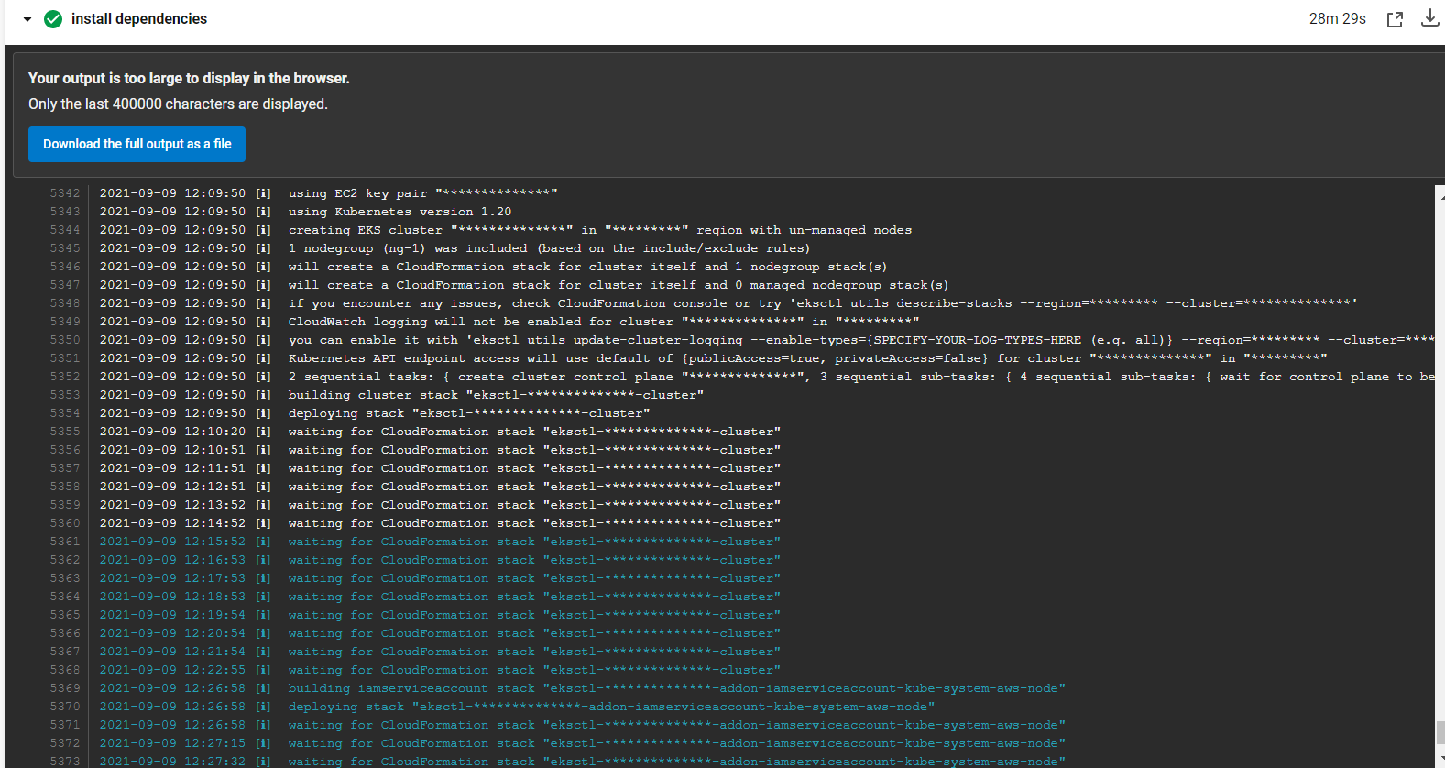

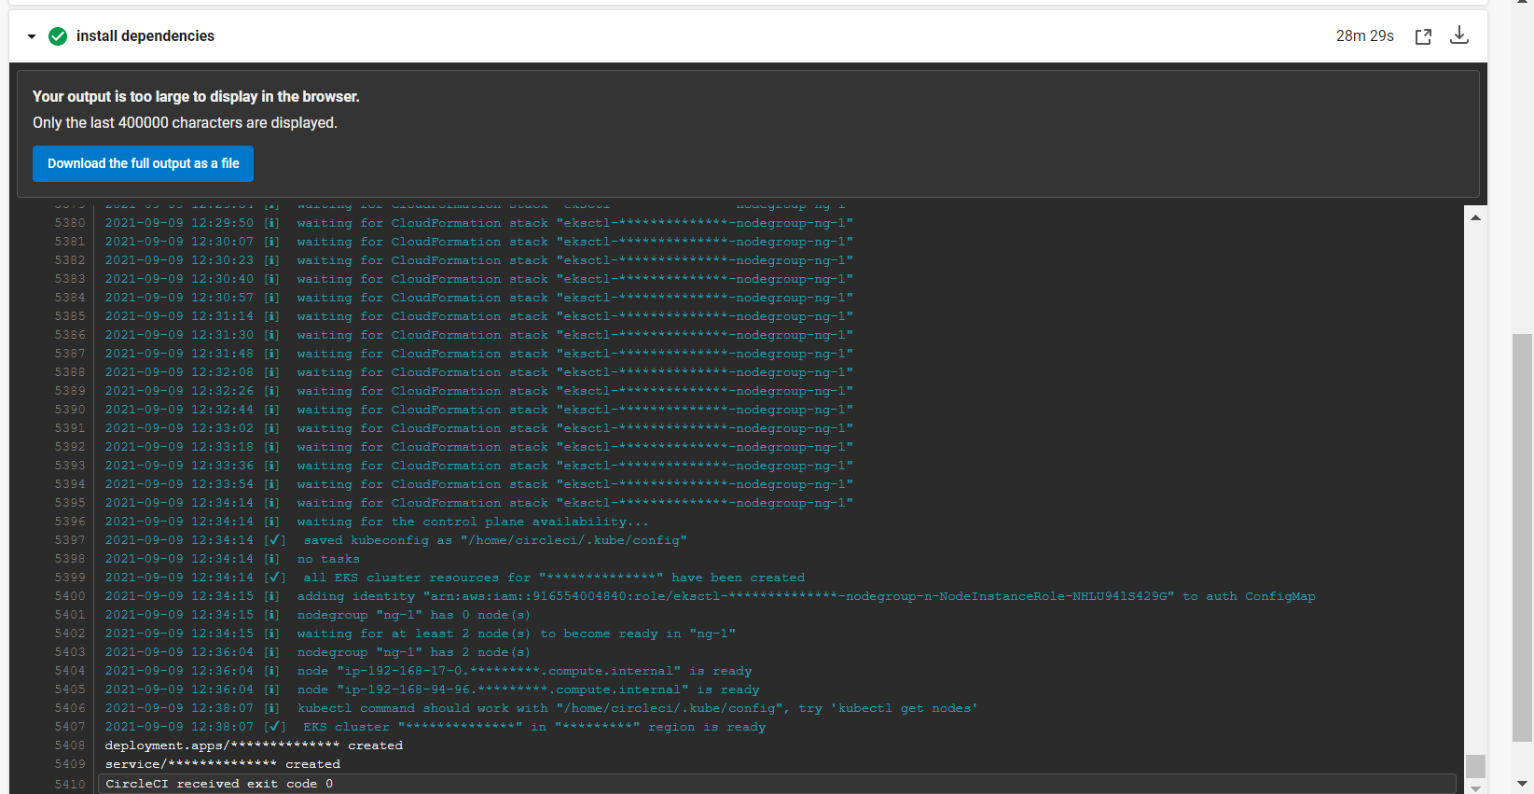

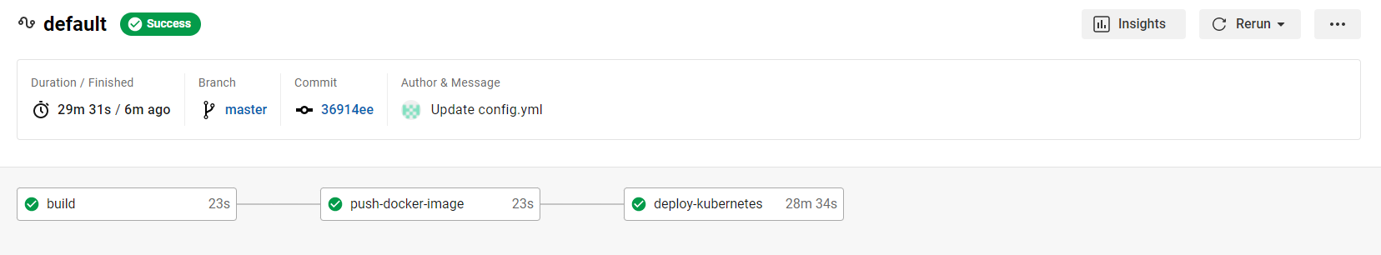

**Load Balancer Creation Screenshot:**

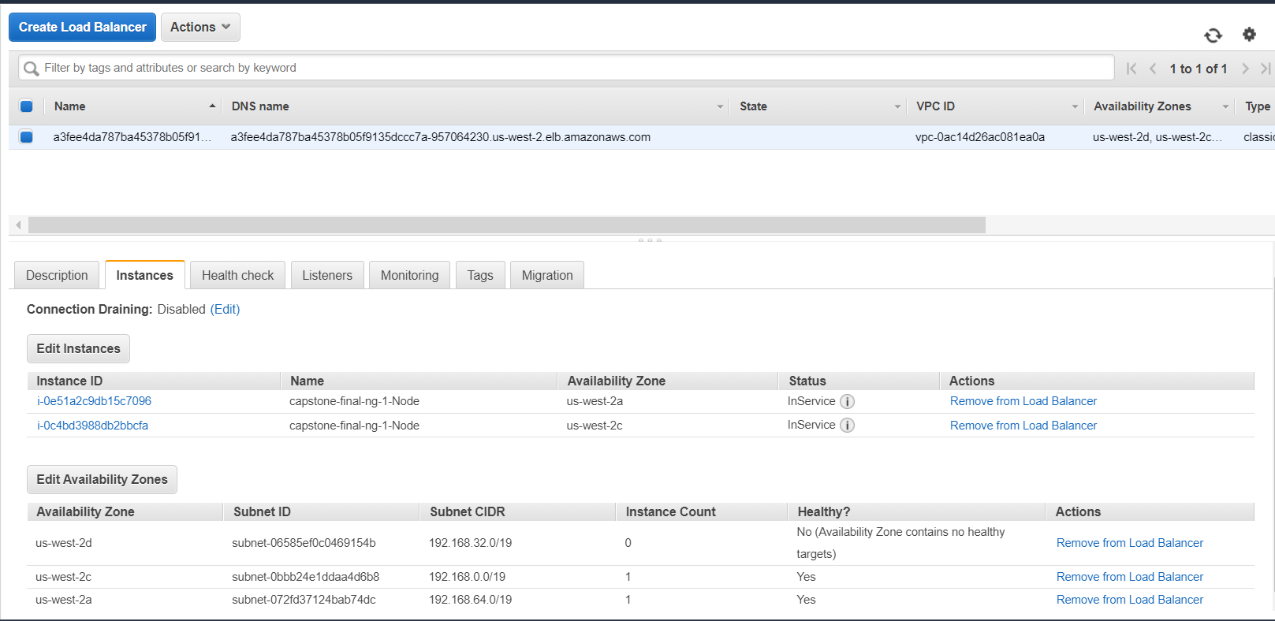

**Webpage First Deployment:**

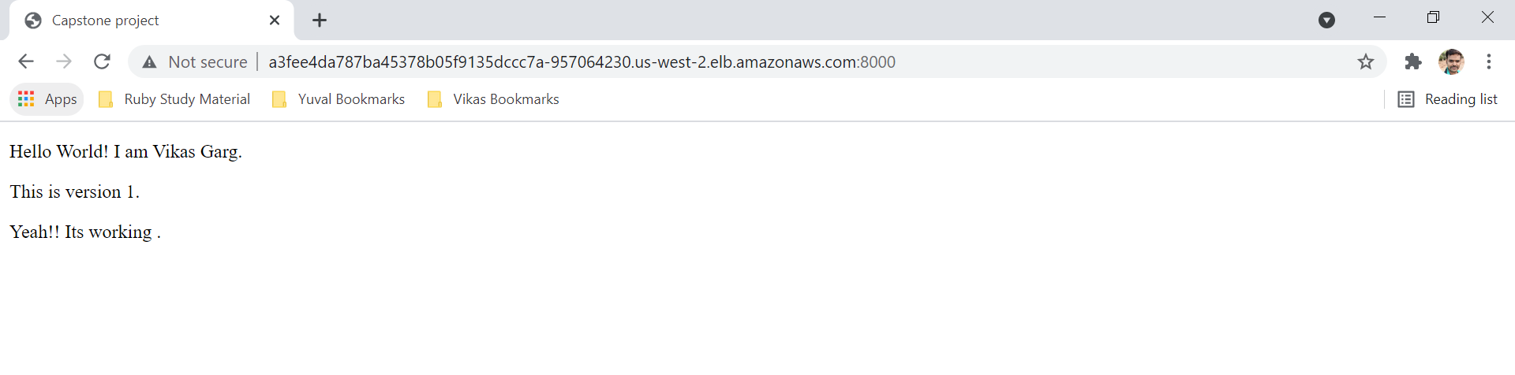

**Updating HTML for Version 2:**

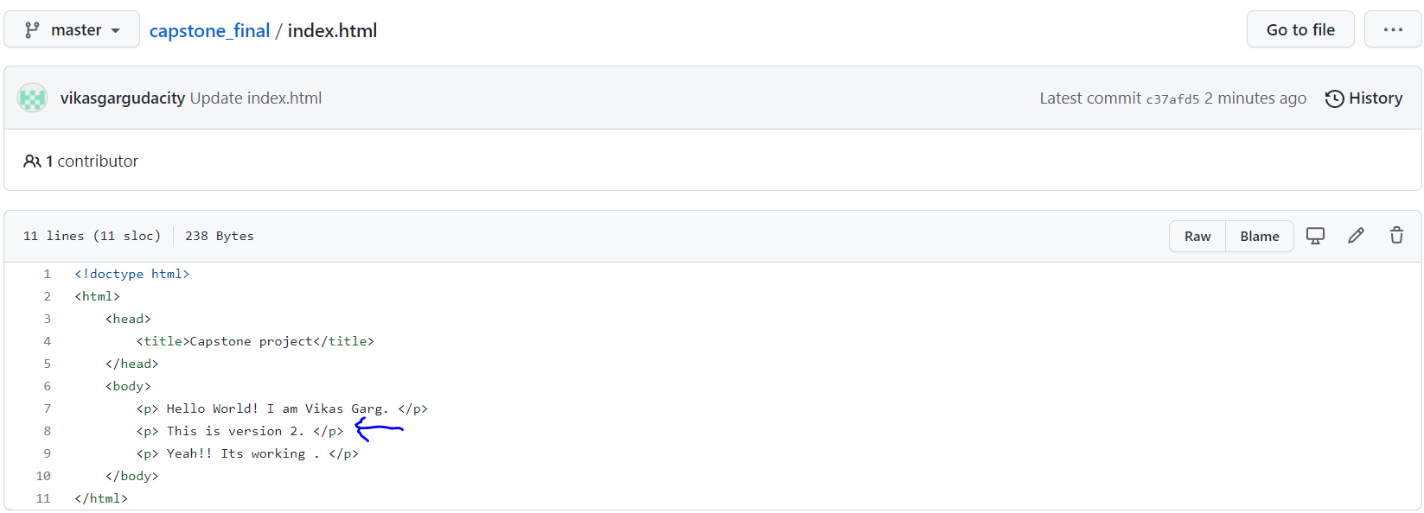

**Rolling Updates completed:**

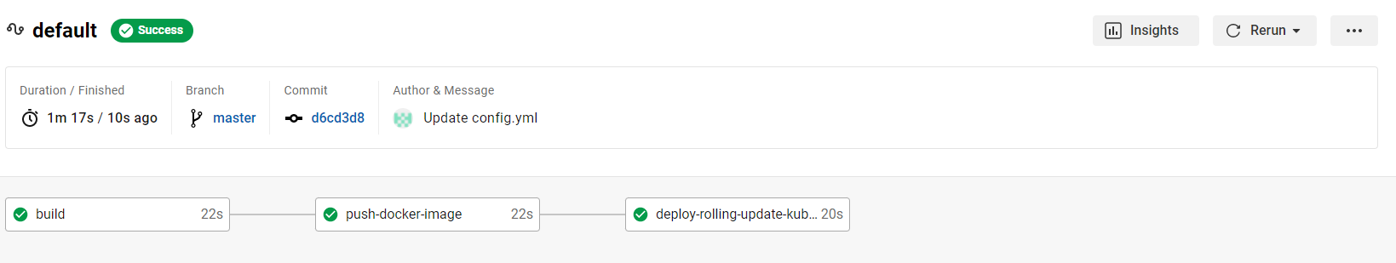

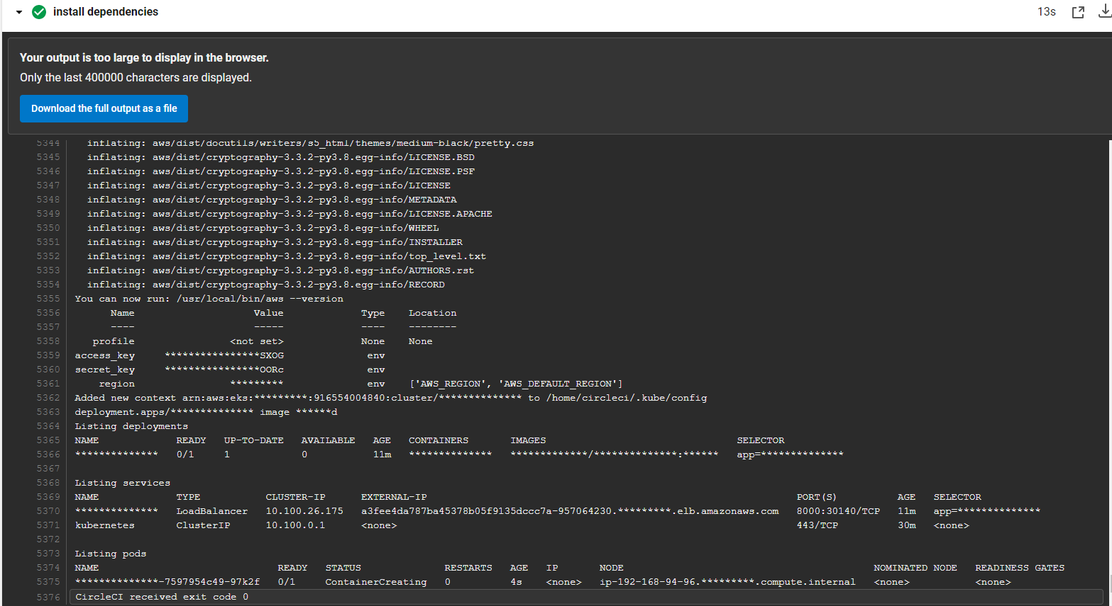

**Updated HTML Page reflected:**

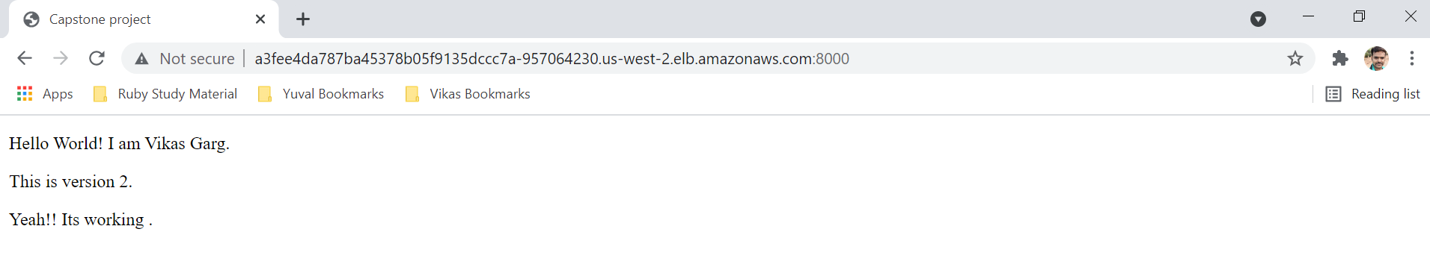

**Rollback the Current deployment:**

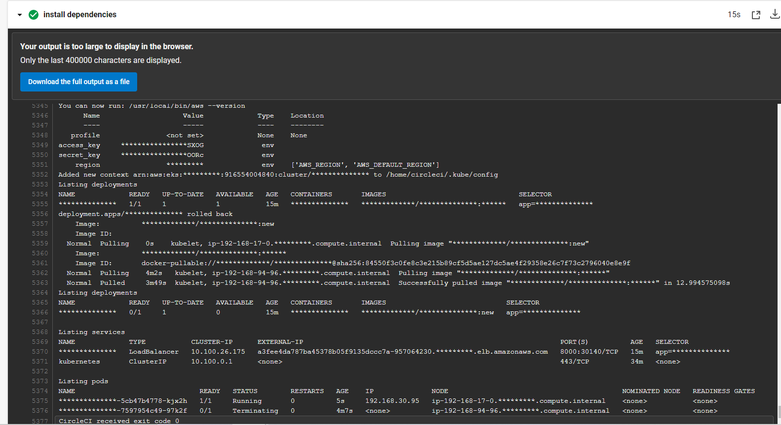

**Load Balancer output Post Roll back:**

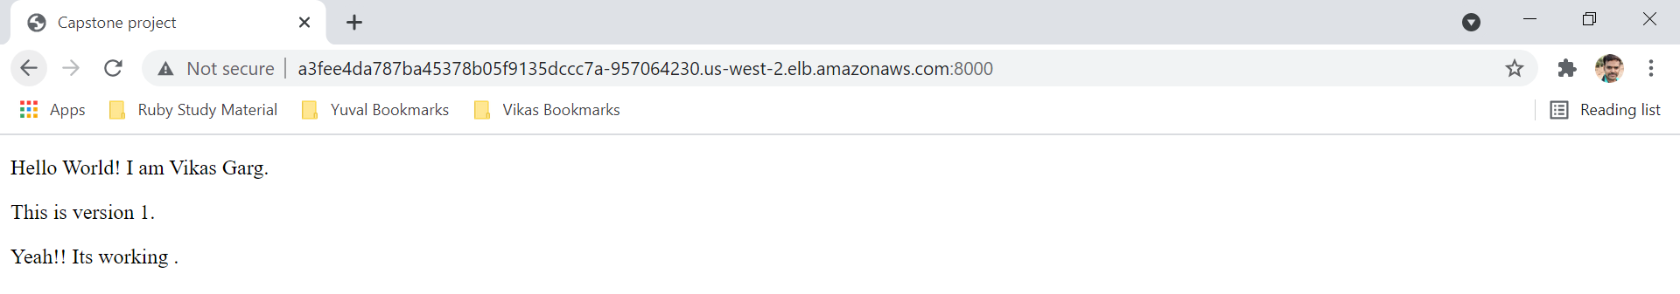

**Cleanup resources:**

